Port Proxy

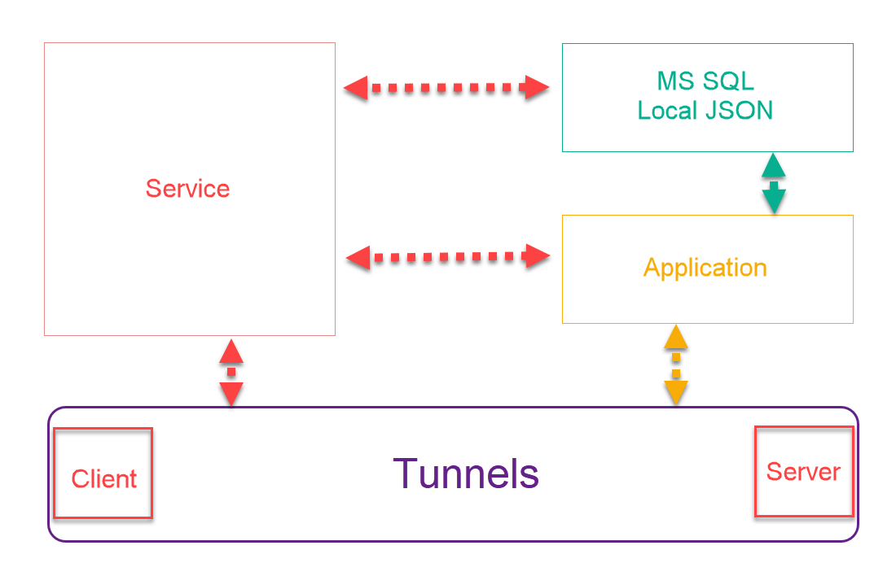

# Storage Modes

* MSSQL
  + Table and Trigger to be controlled by any other application source.
    - Table
      * (ID, Service Name, System GUID, Local IP, Local Port, Remote IP, Remote Port, Connection Type, Expiry Time).
    - Trigger IP:9800 UDP Packet with call “Table Value Changed” which will trigger